Membership Application
Please note your information is kept confidential and is never shared.
Today’s Date: _______________

First Name _________________________ Last Name __________________________
Address ____________________________________City __________________State _____ Zip __________
Date of Birth (MM/DD/YYYY) ________________________ Male/Female
Home Phone ____________________ Cell Phone _______________________
Email Address _________________________________________

Would you like to receive the BCB monthly newsletter and calendar of events? Yes/No
In which Format (select one): email / audible format (by phone)

Would you like to receive ACB’s monthly newsletter, The Braille Forum?
Format (select one): Email / Large Print / Braille / Audio version on CD

BCB encourages our members to get involved and share your skills with us. Please select any areas for which you may be interested in volunteering or serving:
- Committees: £ Membership £ Finance £ Bylaws £ Policies and Procedures
- Other opportunities: £ Fundraising £ Marketing £ Office assistance £ Events £ Board member £Other__________________

Please check if you are: £ Blind £ Vision Impaired £ Normal Vision

Race/Ethnicity: £ Caucasian £ African American £ Hispanic £ Other ______________

Number of people in household: _____________
Combined Household Income: £ $0 - $11,500 £ $11,551 - $16,000 £ $16,001 - $22,000
£ $22,001 – 28,000 £ $28,001 - $37,000 £ $37,001 – 48,500 £ $48,501 or more

Personal and private information collected in this application form is not shared with anyone. Statistics are used for grant writing and other statistical purposes.

Payment Options: (minimum $10 a year per person)
£ Check (payable to Bluegrass Council of the Blind) $______ £ Cash $________
£ Credit Card Please bill my card in the amount of: $_____________
£ One-time charge £ Annually
Credit Card Number _____________________________
Expiration Date (MM/YY)_________________ CVV ________________
Name on Card _________________Signature ___________________________

ABOUT US
__________________
Bluegrass Council of the Blind (BCB) is an affiliate of American Council of the Blind (ACB) which has more than 70 state and special interest affiliates. BCB is the only nonprofit agency in Fayette County exclusively dedicated to the needs of blind and visually impaired adults.

MISSION STATEMENT
The Mission of Bluegrass Council of the Blind is to To increase independence, security and quality of life for Kentuckians affected by vision loss through peer support, technology, training and additional resources.

2200 Wilson Blvd, Suite 650
Arlington, VA 22201
Phone: (800) 424-8666
Fax: (703) 465-5085
Website: www.acb.org
MEMBERSHIP
__________________
Members are crucial to the development and leadership of the organization. Our members provide guidance and direction for BCB staff and programs. For as little as $10 per year, you can become a part of the community that is changing lives of the blind and visually impaired. Membership with BCB also includes membership with the American Council of the Blind (ACB). Together, you will be connected with thousands of individuals who provide support and share information about issues related to vision loss.

BENEFITS
A variety of benefits are available for our members:
- Voting privileges at BCB and ACB meetings
- Eligibility to participate on various committees to advance the operation of BCB.
- Eligibility to apply for financial assistance to attend conferences and conventions.
- Eligibility to be nominated for membership awards.
- Wheels passes will be provided as reimbursement for members who pay for Wheels transportation to and from BCB events.

MEMBERSHIP
__________________
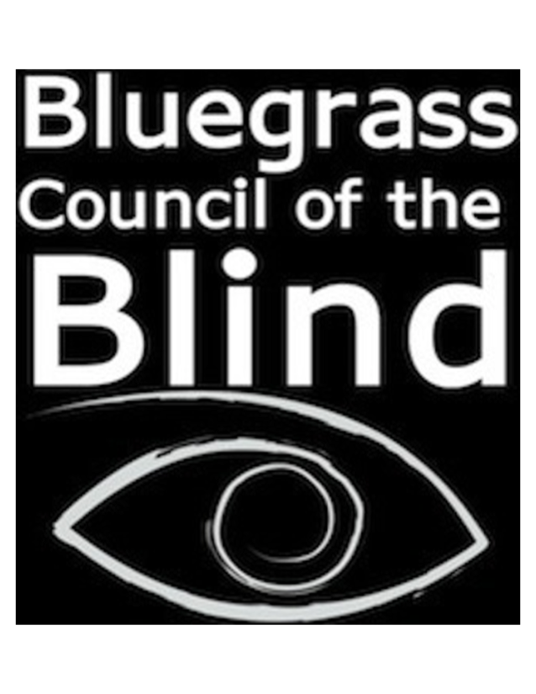
Serving People
Affected by Vision Loss
____________________

Bluegrass Council of the Blind
2265 Harrodsburg Road
Suite 102
Lexington, KY 40504

859-259-1834
info@bcbky.org
www.bcbky.org

