**Bluegrass Council of the Blind, Inc.**

**1093 South Broadway**

**Suite 1218**

**Lexington, KY 40504**

**859-259-1834**

**info@bcbky.org**

**www.bcbky.org**

**Serving People**

**Affected by Vision Loss**

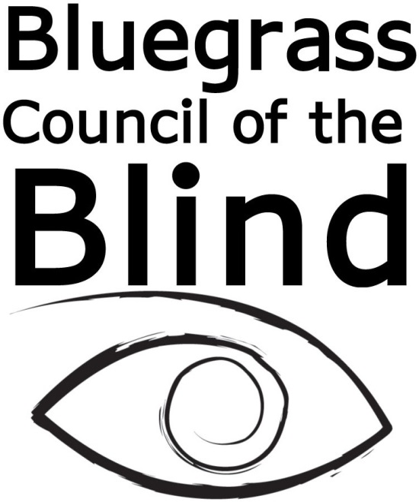

#### Membership

Members are crucial to the development and leadership of the organization. Our members provide guidance and direction for BCB staff and programs. For as little as $10 per year, you can become a part of the community that is changing lives of the blind and visually impaired. Membership with BCB also includes membership with the American Council of the Blind (ACB). Together, you will be connected with thousands of individuals who provide support and share information about issues related to vision loss.

**BENEFITS**

A variety of benefits and services are available for our members:

* Voting privileges at BCB and ACB meetings
* Eligibility to participate on various committees to advance the operation of BCB
* Eligibility to apply for financial assistance to attend conferences and conventions
* Eligibility to be nominated for membership awards
* Wheels passes will be provided as reimbursement for members who pay for Wheels transportation to and from BCB events

#### Membership

#### Stay in Touch

Email : ______________________

* Would you like to receive our bi-monthly newsletter, *eyeKNOW news*, which is the official publication of the Bluegrass Council of the Blind?

□ Yes, I would like to receive it.

Check preferred form:

□ Audio Cassette

□ Large Print

□ Email

□ No, I prefer not to receive it.

* As a member of BCB, you are entitled to receive a free copy of *The* *Braille Forum*, which is the official quarterly publication of the American Council of the Blind.

□ Yes, I would like to receive it.

Check preferred form:

□ Braille □ Audio Cassette

□ CD-ROM □ Large Print

□ Podcast □ Email

□ No, I prefer not to receive it.

Bluegrass Council of the Blind (BCB) is an affiliate of American Council of the Blind (ACB) which has more than 70 state and special interest affiliates. BCB is the only nonprofit agency in Fayette County exclusively dedicated to the needs of blind and visually impaired adults.

**MISSION STATEMENT**

The Mission of Bluegrass Council of the Blind is to provide resources and services to all people affected by a loss of sight; improving lives for all by empowering persons with the loss of vision to continue living independently as productive, contributing members of their community and to educate the public on rights, abilities, and needs of the visually impaired. Services are inclusive of anyone directly or indirectly impacted by the loss of sight.

#### About Us

 1703 N. beaurgard St   
Suite 420  
Arlington, VA 22201

 Phone: (800) 424-8666

Fax: (703) 465-5085

Website: www.acb.org

Email: info@acb.org



**American Council of the Blind**

Please return form and payment to

Bluegrass Council of the Blind

1093 S. Broadway Ste. 1230

Lexington, KY 40504

First Name _________________________ Last Name __________________________

Address _______________________ City __________ State _____ Zip __________

Date of Birth (MM/DD/YYYY) ____________________________ Male/Female

Home Phone ____________________ Cell Phone _______________________

Please check if you are: □ Blind □ Vision Impaired □ Normal vision

Diagnosis ______________________ Visual Acuity ___________________ (i.e. 20/200)

Ophthalmologist or Optometrist ________________________________

Company __________________________Location___________________________

BCB is a small nonprofit, with a small staff. We depend on volunteers to help us provide our services and assist in fundraising. Please check all areas you’re interested in:

* Committees: □ Membership □ Finance □ Bylaws □ Nominating
* Other opportunities: □ Fundraising □ Marketing □ Office assistance □ Events

□ Board member □Other__________________

Membership Levels: (please choose from the following)

□ $10-$49 *Contributor* □ $150-$299 *Guide*

□ $50-$149 *Leader* □ $300 and up *Visionary*

Membership Category**:** (please select one of the following)

□ Voting Member (participates in BCB activities and decision making)

□ Supporting Member (supports BCB programs and services, non-voting membership)

Ethnicity: □ Caucasian □ African American □ Hispanic □ Other _______________

Number of people in household: _____________ Business affiliation? ____________________

Combined Household Income: □ $0 - $11,770 □ $11,771 - $15,930 □ $15,931 - $20,090

□ $20,091 – 24,250 □ $24,251 - $37,600 □ $37,601 – 48,350 □ $48,351 or more

*All information collected is kept confidential and not shared with anyone. This information will be used for grant writing and other statistical purposes only.*

**Payment Options**

□ Check (payable to Bluegrass Council of the Blind)

□ Cash

□ Credit Card

Please bill my card in the amount of: $_______

□ One-time charge □ Monthly □ Quarterly □ Annually

Credit Card Number _____________________________

Expiration Date (MM/YY)_________________ Credit Card Type ____________

Name on Card _____________________ Signature __________________________

Billing Address _____________________City __________State _____Zip________